**Assignment No 1**

#include<stdio.h>

#include<conio.h>

void main()

{

clrscr();

float product_price;

float x=0.05; // Discount on the printed price

float y=0.03; //customer pay an sales tax on discount price

//clrscr();

printf("The Price of product is:\n");

scanf("%f",&product_price);

float dis_price=product_price*x;

printf("discount amount:%f \n", dis_price);

float dis_amount=product_price-dis_price;

printf("Price of Product After Discount:%f \n",dis_amount);

float salestax_amount=dis_price*y;

printf("Customer Needs to Pay Sales Tax on Discount Amount:%f \n",salestax_amount);

printf("The total Amount need to pay By customer is:%f \n",dis_amount+salestax_amount);

getch();

}

**Output:**

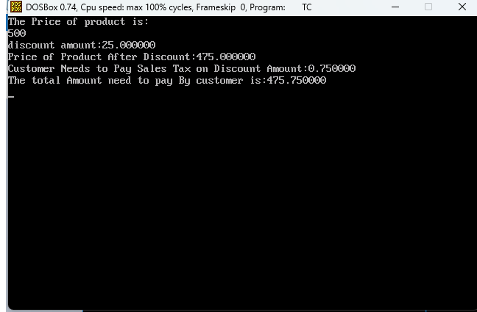

d